Mylan AIX Migration from 7.1 to 7.2 Through VIO Repository Handbook - version 1.1

Table of contents
1. Scope and Role of the NW resource 4
1.1. Purpose 4
1.2. Scope and Role of the NW resource 4
1.3. Skills, capability and structure of the NW Resource 4
2. Access management 5
2.1. Purpose 5
2.2. Access components 5
2.3. Access management WI’s 5
3. WAN & LAN management 6
3.1. Purpose 6
3.2. WAN & LAN components 6
3.3. WAN & LAN management WI’s 6
4. WLAN management 7
4.1. Purpose 7
4.2. WLAN components 7
4.3. WLAN management WI’s 7
5. SD-WAN management 8
5.1. Purpose 8
5.2. SD-WAN components 8
5.3. SD-WAN WI’s 8
6. Infra Management 9
6.1. Purpose 9
6.2. Infra Management components 9
6.3. Infra Management WI’s 9
7. Miscellaneous task management 22
7.1. Purpose 22
7.2. Miscellaneous components 22
7.3. Miscellaneous task Management 22
8. Version Control 23
8.1. Purpose 23
8.2. Revision History 23
Appendix A. - Appendix Page 24
A.1. Example - This is Appendix Heading 2 24
A.1.1. Example - This is Appendix Heading 3 24

Scope and Role of the NW resource

Purpose
[Provide a brief description of the purpose of a PMO within a programme]

Scope and Role of the NW resource
[Define the programme management arrangements the PMO will (and will not) deliver according to the requirements of the programme]

Skills, capability and structure of the NW Resource
[Describe how the PMO function is organised and resourced]
[The following example table can be used to outline the PMO team members and their roles]
Functional role | Responsibilities & Accountabilities
WAN | Runs the main logs and processes that underpin the programme, reporting on
Manager | Supports the programme manager in managing the productivity and wellbeing of the team. Develops and implements resource management arrangements and manages resources
Contract Manager | Develops and implements supplier management and manages suppliers.
Manager | Establishes and maintains the programme plans. Works with workstream and/or project leads to coach them.

Access management

Purpose
[Provide a brief explanation to the issue management strategy for the programme].
User to go through the WI’s to raise the required access to perform the day to day task

Access components
User to follow the below mentioned Wi’s in order to raise the request for the particular access

Access management WI’s
User to follow the below mentioned Wi’s in order to raise the request for the particular access

WAN & LAN management

Purpose
[Describe the process and management of the Change Control function]

WAN & LAN components
[Describe the process and management of the Change Control function]

WAN & LAN management WI’s
[Describe who and when Change Control requests can be made]

WLAN management

Purpose
[Describe the performance monitoring and reporting process for the programme]

WLAN components
[Describe the performance monitoring and reporting process for the programme]

WLAN management WI’s
[Describe what the reporting requirements are and to who the status updates will be reported to and on what frequency]

SD-WAN management

Purpose
[Describe the financial management process for the programme e.g. the purpose of financial management will be to establish, monitor and control financial resources in order to ensure that the programme is delivered efficiently, within budget and delivers the expected financial benefits]

SD-WAN components
[Provide reference to Finance Reporting Template/Budget Template that is in use for the programme]

SD-WAN WI’s
[Provide reference to Finance Reporting Template/Budget Template that is in use for the programme]

Infra Management

Purpose
This document provides the steps to migrate the AIX OS version from AIX 7.1 to AIX 7.2.

Infra Management components

6.2.1. Operating System AIX 7.2 Base ISO Images. We can download it from URL https://www.ibm.com/servers/eserver/ess/ProtectedServlet.wss#toggle
6.2.2. We can download TL Update from fix central URL https://www.ibm.com/support/fixcentral
6.2.3. VIO server should have enough free space in rootvg to create virtual media repository.
6.2.4. AIX Client LPAR must have 40% free disk space in rootvg

Infra Management WI’s

6.3.1. Login to the Aix LPAR (in which OS will upgrade) with MID and switch to root. Find out the VIO server, Vhost detail to map virtual optical device by issuing below command.
# echo "cvai" | kdb | grep vscsi

6.3.2. Create the virtual optical media device with SOP “MYL-UNX-SOP-VOD-001” and map to client AIX LPAR.
6.3.3. Boot the AIX LPAR in SMS mode, meanwhile login HMC with MID and take console of AIX LPAR.
In Manages Systems, Choose “0BPS202--SN068242P” by Type “2” in navigation key field
Note : 0BPS202--SN068242P (Manged Machine where the LPAR is present)
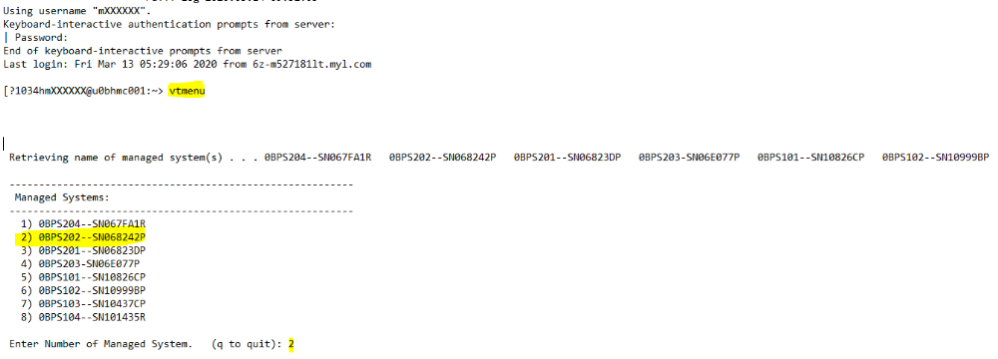
In Partitions On Manages System, Choose “0bps101_u0bnim001” by Type “1” in navigation key field.
Note : Select LAPR Name which you want to migrate.
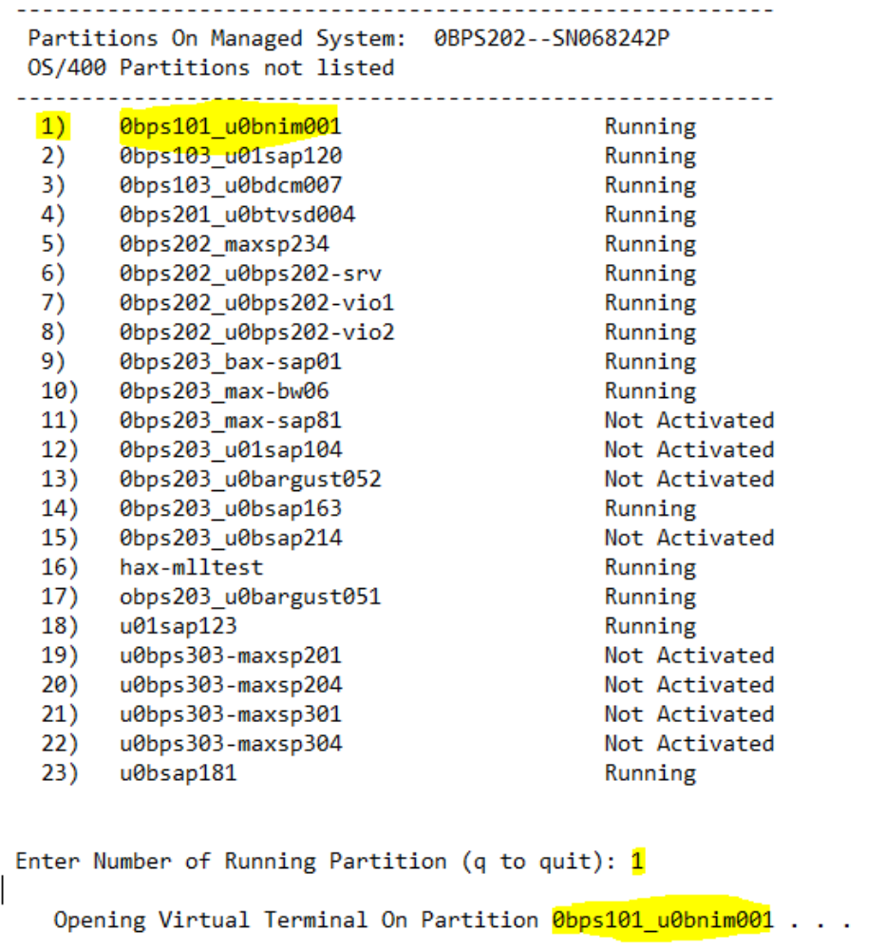

6.3.4. In SMS mode menu, Choose “Select Boot Options” by Type “5” in navigation key field

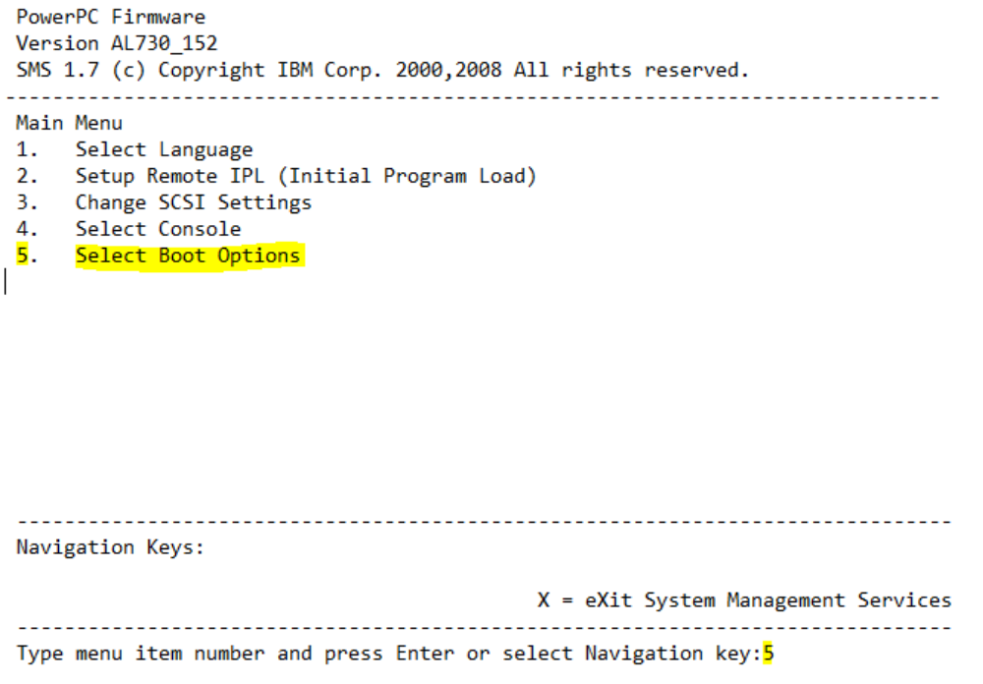

6.3.5. In Boot Options, Choose “Select Install/Boot Device” by Type “1” in navigation key field

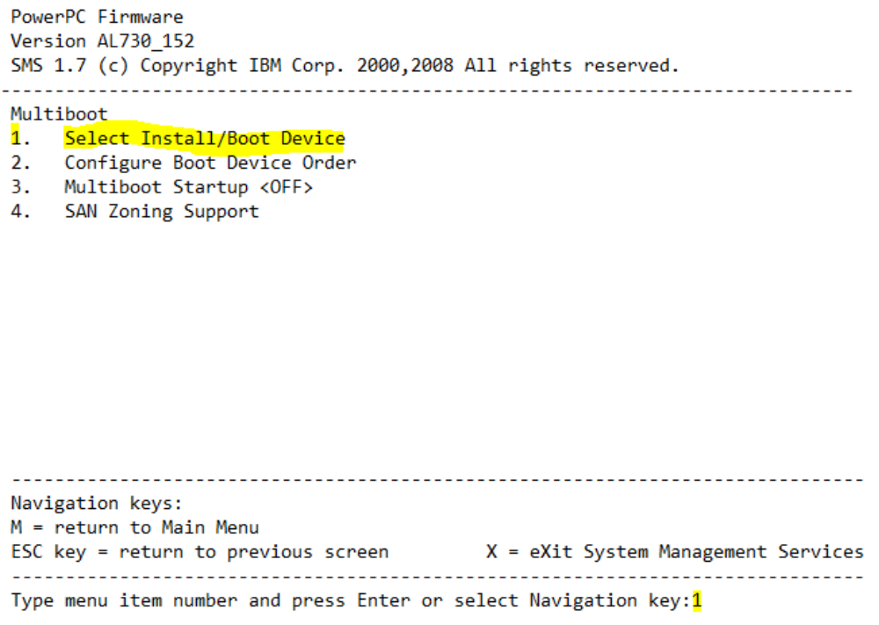

6.3.6. In Select Device Type options, Choose “List all Devices” by Type “7” in navigation key field

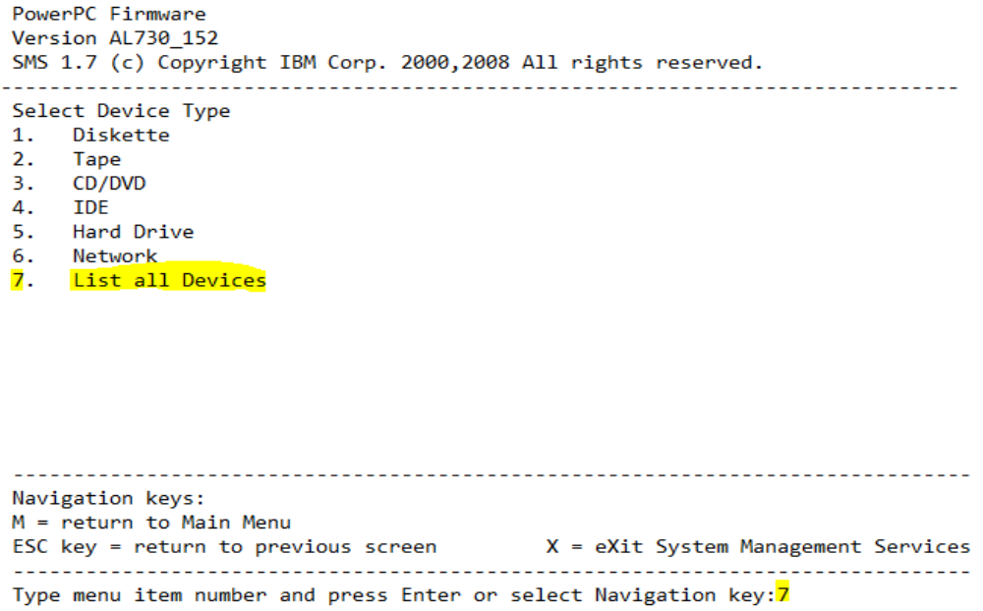

6.3.7. In Select Device menu, Choose CD-ROM by Type “2” in navigation key field

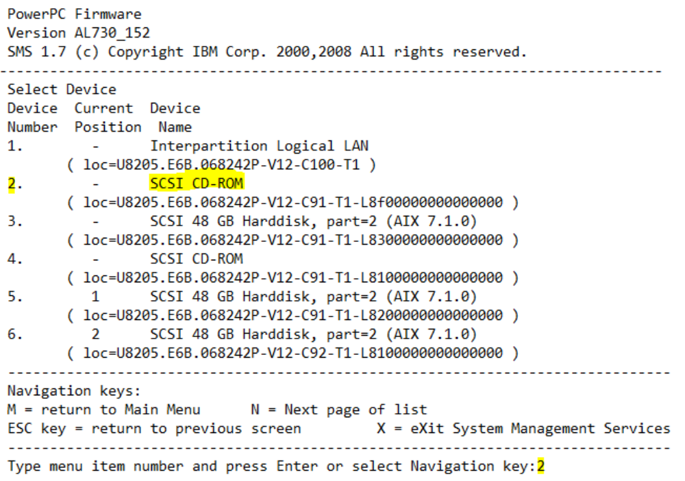
Note: SCSI CD-ROM is the virtual optical device mapped from VIO server

6.3.8. In Select Task Menu, Choose “Normal Mode Boot” by Type “2” in navigation key field

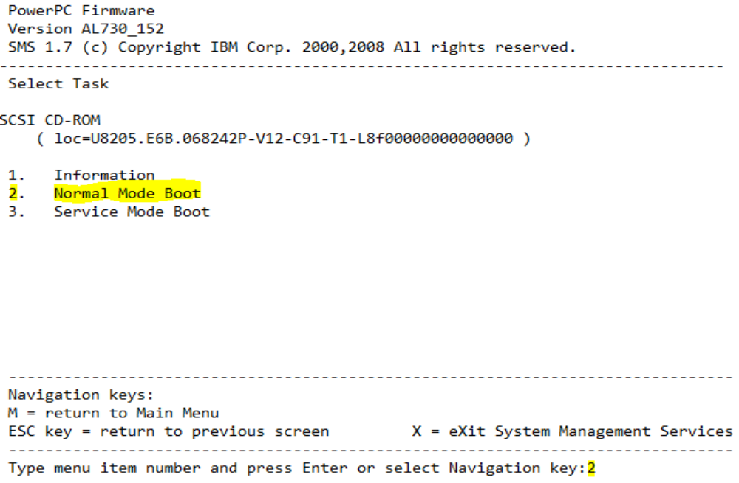

6.3.9. Save the Boot configuration and exit from SMS menu by Type “1” in navigation key field

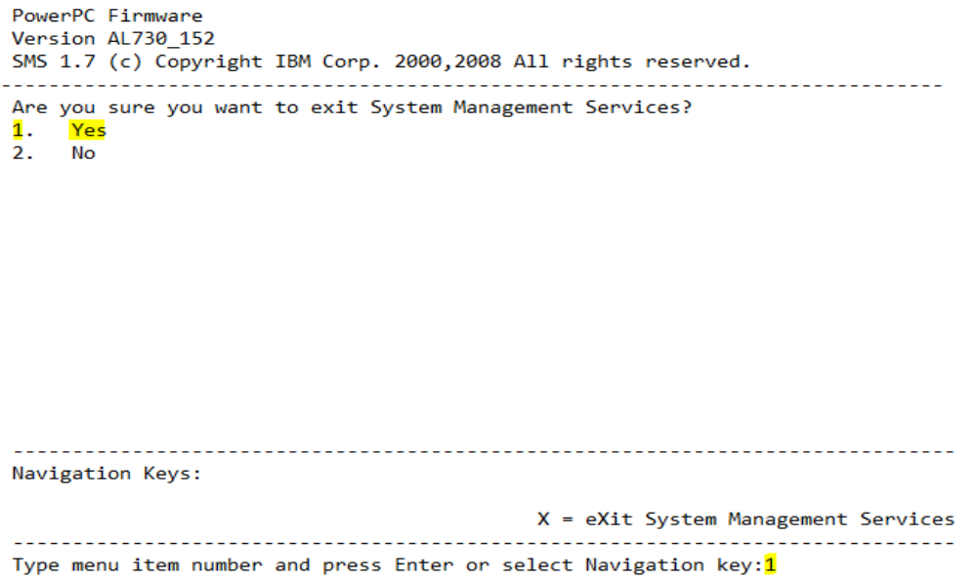
Note: Server will reboot after exit from SMS menu

6.3.10. Now server will boot with CD-ROM which having Bootable BOS image. Now Type a 1 and press Enter to use this terminal as the system console

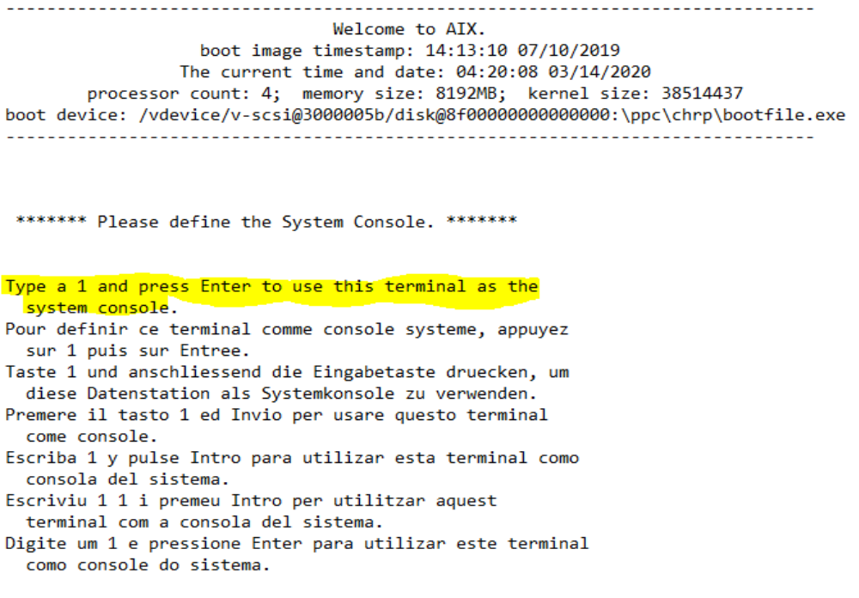

6.3.11. Select Installation Menu Language by Type 1 and press Enter to have English during install. Now BOS installation and Maintenance window will open

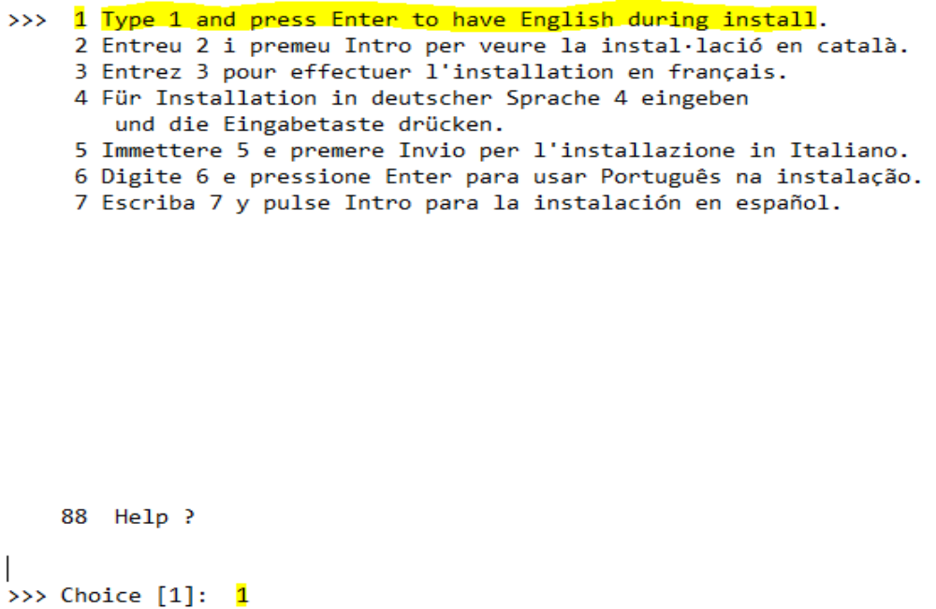

6.3.12. Type 2 and Choose “Change/Show Installation Settings and Install” in BOS Installation and Maintenance

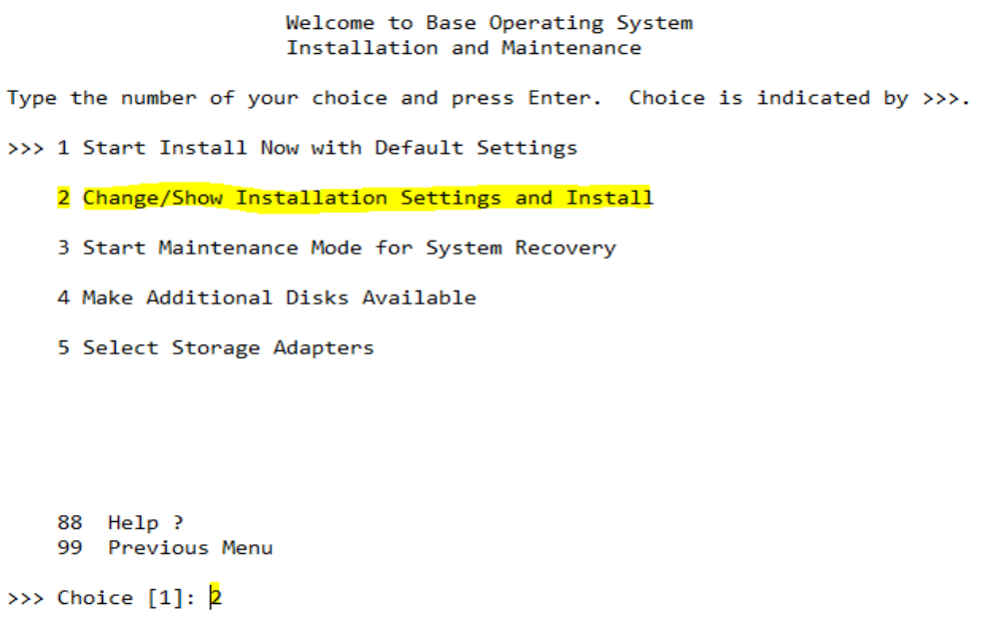

6.3.13. In the Installation and Settings window, Type 1 and press enter to select “System Settings”, then Change method of Installation menu will open.

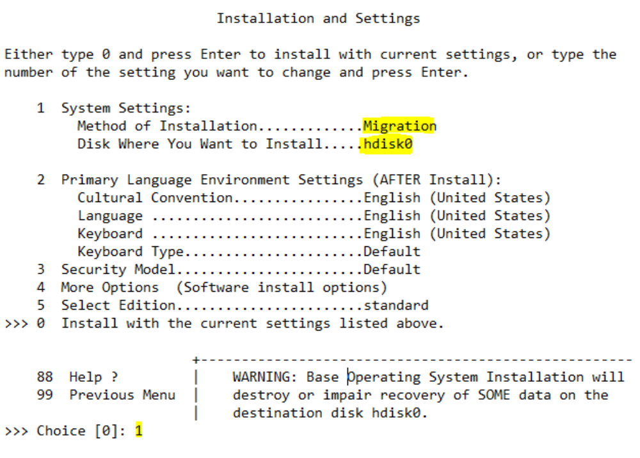

6.3.14. Change method of Installation menu, Type 3 and press enter to choose Migration Install. Now “Change Disks where You Wants to Install” menu will open

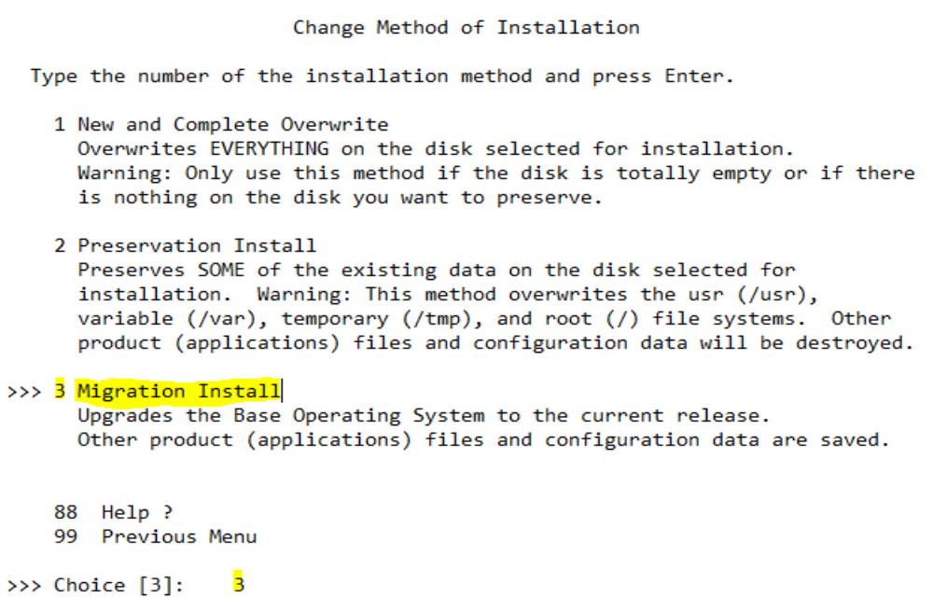

6.3.15. In Change Disks where You Wants to Install menu, Type “77” and press enter to Choose “Display More Disk Information”

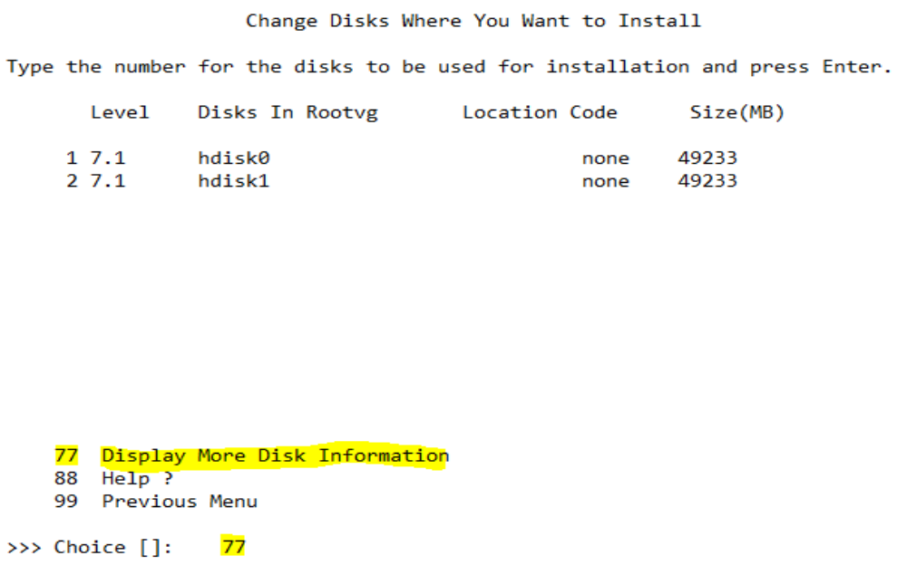

6.3.16. Identify the PVID of root vg disk, where we upgrade the OS. In this list Select option 1 So that you perform OS migration on hdisk0 and hdisk1 having old OS for roll back if migration fails

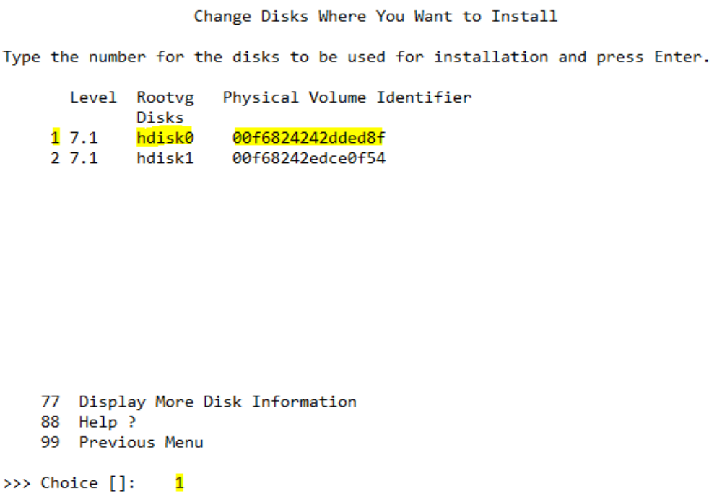

6.3.17. In the Installation and Settings window, Type “0” and press enter to select “Install with the current settings listed above”.

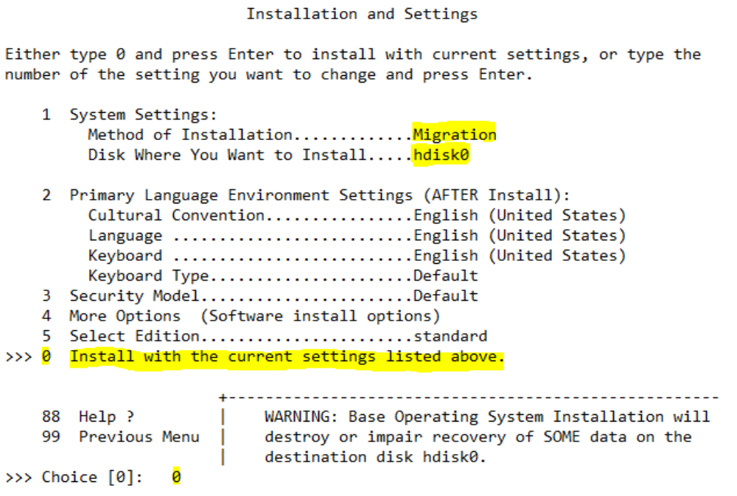

6.3.18. Review the summary and Type “1” and press enter to select “continue with Install”

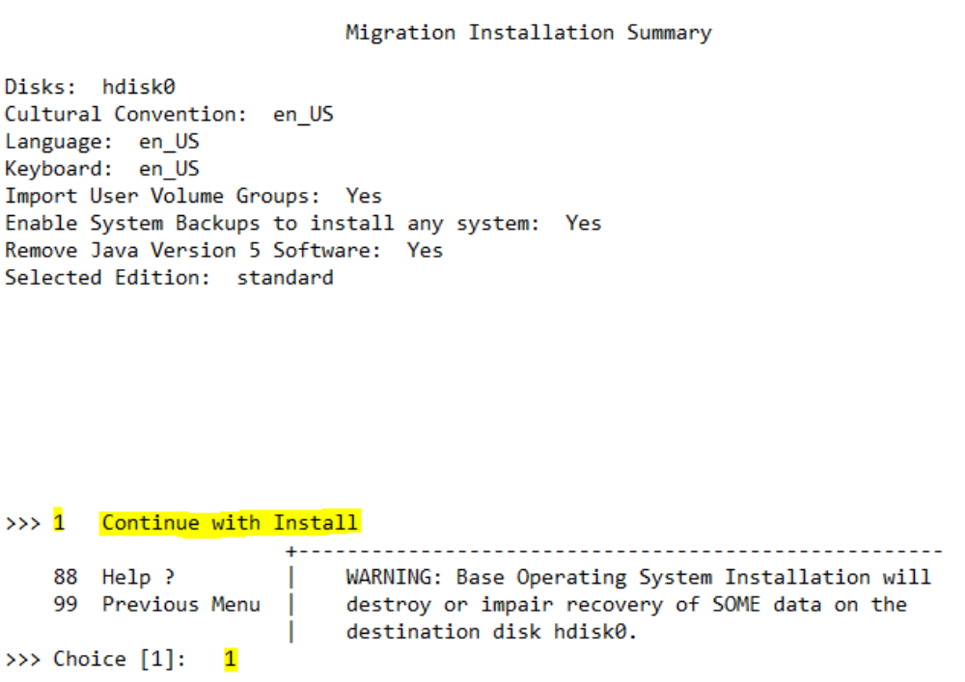

6.3.19. After completion file sets installation set the terminal type as vt100 and press enter.

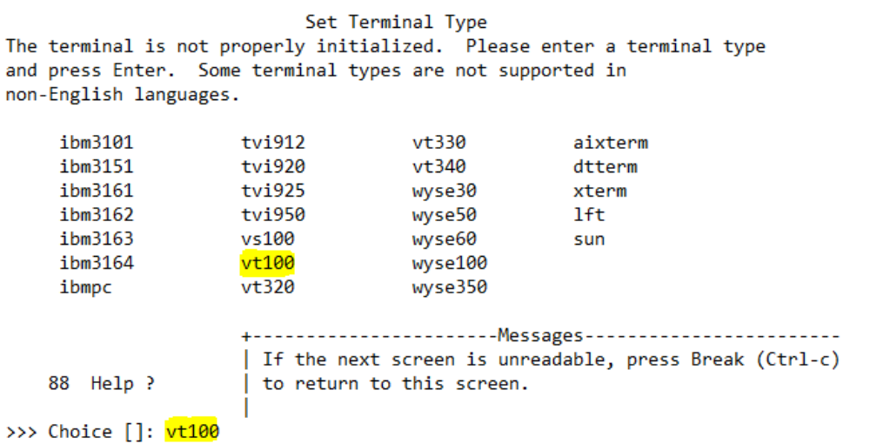

6.3.20. Once server came up. Check the OS level by issuing the below command.
# oslevel -s
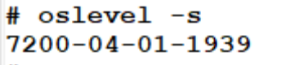

6.3.21. Check the known recommended maintenance levels by issuing below command.
# oslevel -rq
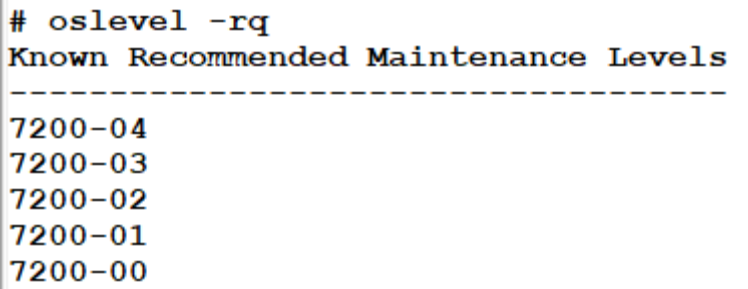

6.3.22. Check the known service packs by issuing the below command
# oslevel -sq
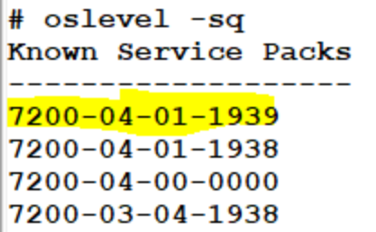

6.3.23. Once Application team confirm we can mirror the rootvg Disks by issuing the below command.
# mirrorvg rootvg hdiskX (Here hdisk4 is the new free physical volume)
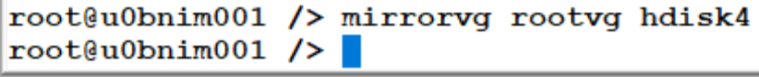

6.3.24. For rollback, change the bootlist and reboot the server, server will boot with Old OS version and it packages. Post we can Mirror the rootvg disks
Change the bootlist order by issuing the below command
# bootlist -m normal hdisk3 (Here hdisk3 is old rootvg physical volume)
Check the bootlist order by issuing the below command.
# bootlist -m normal -o
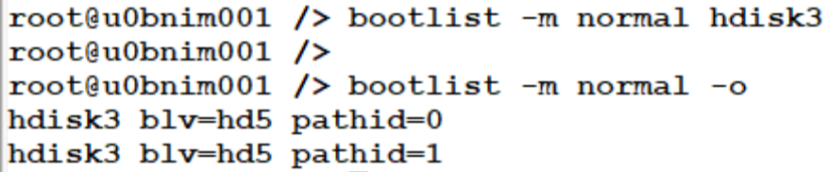

Miscellaneous task management

Purpose
[Describe the Quality Management approach that is being used across the programme and make reference to any plans and quality logs]

Miscellaneous components
[Describe the process for detailing the quality verification and validation activities to be used across the programme]

Miscellaneous task Management
[Describe the process for detailing the quality verification and validation activities to be used across the programme]

Version Control

Purpose
[Describe the Document Control procedures that are in place for the programme]

Revision History

Date | Version | Summary of Changes | Author | Approved by
May 19 2021 | V 1.0 | Updated Organization Detail | Franklin Kabila Dhas | Arunachalam G
Apr 5 2023 | V1.1 | Updated in New Template | Ashok Kumar RK | Mohandoss Murugesan

- Appendix Page
  - Example - This is Appendix Heading 2
Example Body text - Georgia 10
    - Example - This is Appendix Heading 3
Example Body text - Georgia 10 with a in the text

